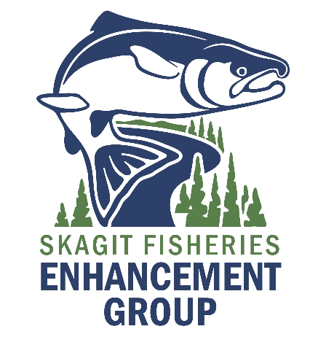
June is Orca Action Month! Show off your art skills and win a prize! Complete your artwork on the back of this sheet.

PROMPT: What is the relationship between salmon and orcas? Why is this relationship Important to the Skagit Watershed?
Show us how by creating a drawing, painting, or collage! No digital art will be accepted. This contest is for children ages 14 and under.

Physical copies must be submitted to the Children’s Museum of Skagit County at 432 Fashion Way, Burlington or mailed to 1202 S 2nd St., Mount Vernon, WA 98273 no later than 4 pm on June 21st 2023.

Name ____________________________________________

Age _____________

For Parents:

How can we contact you if your child wins?

Phone number ______________________________________________________________________

Email _______________________________________________________________________________

Please complete your art on the other side of this paper!

