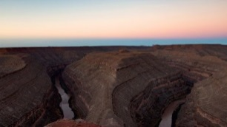
Wild & Scenic Film Festival Oct 26, 2018 Featured Films:

A Letter to Congress Wallace Stegner’s 1960 letter to Congress about the importance of wilderness is the framework for a new message, one in which our unified voice can help prevent the transfer of our most valuable heritage— our public lands— to private and corporate interests.
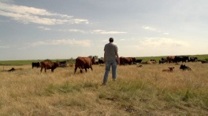
During the Drought A Kansas Farmer, Michael Thompson, regenerates his soils with no-till, cover-crops and Adaptive Multi-Paddock (AMP) grazing - giving his farm resilience during the severe 2011 and 2012 droughts.
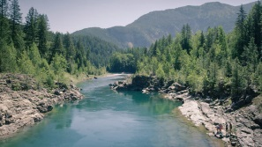
Every Bend Three Montanans talk about how clean, free-flowing, wild rivers enrich their lives. We focus on the power of the Wild and Scenic Rivers Act and how it has benefited just a few Montana rivers, and relatively few nationwide. In doing so, we are reminded of what is at stake if we don’t protect more of our cherished rivers.

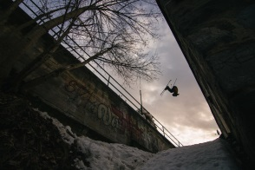
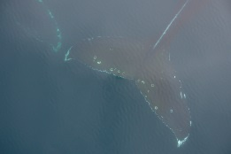
PATAGONIA AZUL, the Interconnection of Life Focused on the blue whales of Northern Patagonia and the scientific efforts that are being developed to understand and protect this majestic animal and its ecosystem, Patagonia Azul, the interconnection of life, emphasizes the interconnection of the web of life. The material, obtained after 4 years of scientific expeditions in the area of the Gulf of Corcovado and its surroundings, explains the objectives of these investigations, and the goal of the scientific and private efforts to preserve the largest animal in the history of mankind: the blue whale.

Imagination: Tom Wallisch We’ve all been that kid sitting in the back seat of our family car, wishing we were somewhere else. Through the boredom, the driveway snow piles, sidewalk handrails and stair sets start to tease our inner skier. Watch day dreams come to life as Tom Wallisch shreds the snowy streets of Nelson, British Columbia.
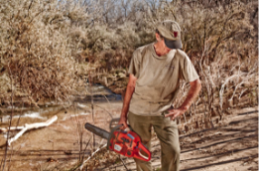
Love of Place When an invasive species plant threatens to take over a beautiful desert river, an obsessive park ranger sets out to kill it.

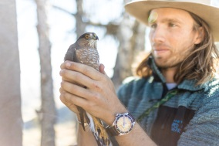

Sky Migrations Each fall, our skies fill with the wings of migrating raptors, a migration that relies on two hemispheres worth of wild and healthy ecosystems. Join ecologist and filmmaker, Charles Post, as he shines a light on the network of back country scientists and sentinels at the front lines of raptor conservation.
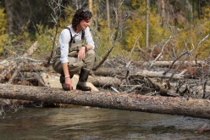
The Fix Chinook salmon swim 850 miles from the ocean to Idaho to spawn in the Yankee Fork of the Salmon River. When the endangered fish arrive, they find a watershed turned upside down by a gold dredge. The Fix explores the daunting task of fixing a broken river.
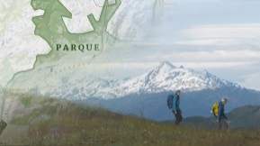
The Nature of Maps Marty Schnure and Ross Donihue are modern day pioneers: roaming some of the world’s last remaining wild lands to create maps to help conserve these precious places. Through their project with conservationist Kris Tompkins and Conservacion Patagonica to map the new Patagonia Park in Chile, The Nature of Maps explores the integral role maps play in conservation, adventure and our understanding of wild places.
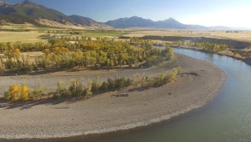
The Shape of a River At its core, The Shape of a River celebrates the Mighty Yellowstone as both partner and provider, ever-shaping the land and lives of those along its course and binding us to the very spirit of wildness. The film casts the story of the River through the eyes of those whose lives intersect with it in ways that run deep. Through them, we find a river that is fierce yet fragile, robust yet at risk.
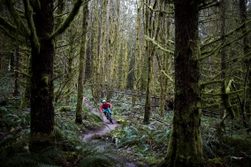
Where the Wild Things Play Friday night at the local watering hole and … where the ladies at? Answer: BASE jumping from high desert cliffs, performing tricks on slacklines, climbing granite routes, shredding singletrack, skiing backcountry lines and generally leaving you fellas behind. This rowdy ode to female athletes by Krystle Wright leaves no doubt about the state of women in today’s outdoor world: badass.

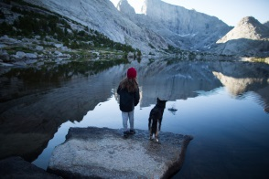
Wild Olympics Follow paddlers Adam and Susan Elliott as they kayak, fish, packraft and explore the wild rivers of the Olympic Peninsula. The peninsula’s wild rivers provide clean water, world-class recreation and unmatched opportunities for inspiration and solitude. They bring jobs and economic benefits to local communities and provide critical habitat for salmon, steelhead and a variety of other fish and wildlife. Wild and Scenic designation–the strongest protection a river can receive–ensures that the free-flowing character, water quality and outstanding values of these rivers are protected for generations to come.

