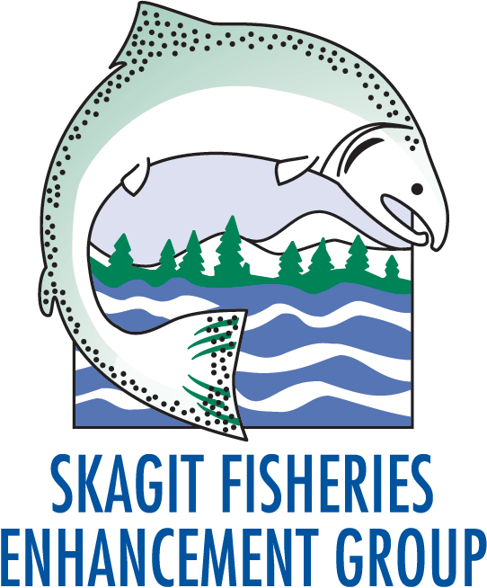
Environmental Education Internship
Fall 2017

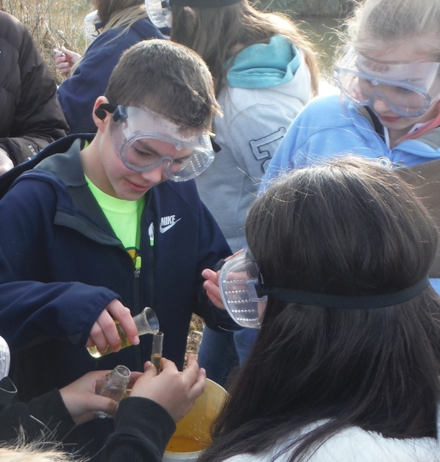

The Environmental Education intern will assist SFEG staff and volunteer with classroom and field instruction for school based programs throughout Skagit County. Student programs include hands-on field and classroom activities on topics such as salmon biology and habitats, chemical and biological water quality monitoring, and native plants. Typical age of students is 4th to 8th grade. The intern would assist with watershed field trips and stream restoration service-learning projects throughout the spring.

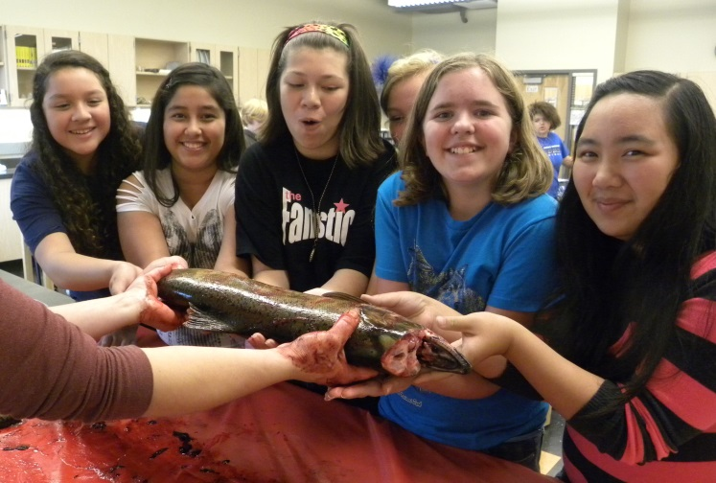
Qualifications
Must have a general knowledge of and/or interest in stream ecology, salmon biology, and/or salmon habitat. Must be organized and self-starting and have some experience and comfort level working with middle school aged children. Must be comfortable working outdoors in adverse weather and able to work well as part of a team. Must have a reliable vehicle. Prefer a student that is pursuing a degree in Environmental Education or Education and is a junior or senior.

Time Commitment
The internship will take place during the school year (mid-September through mid-June). Arrangements can be made for quarter-long, semester-long, or year-long terms. Time commitment depends on time available per month. This is a volunteer position, however mileage reimbursement from our Mount Vernon office to a site or school may be considered if personal vehicle is used.

Interested?
Please contact Lucy DeGrace at 360-336-0172 for more information.
To apply submit a letter of interest, resume and weekend availability to ldegrace@skagitfisheries.org.
More information at: www.skagitfisheries.org

The Skagit Fisheries Enhancement Group is a nonprofit, tax-exempt charitable organization (tax ID# 94-3165939) under Section 501(c)(3) of the Internal Revenue Code.

Help Inspire Stewardship!

