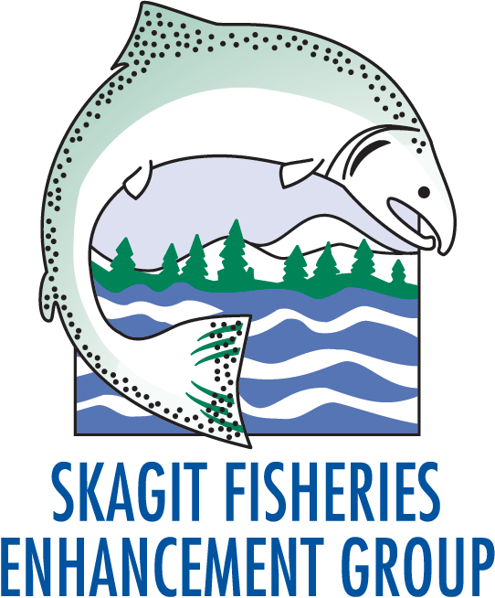
Marketing, Design, and Communications Internship
Summer 2017

Communications, Journalism, Graphic Design

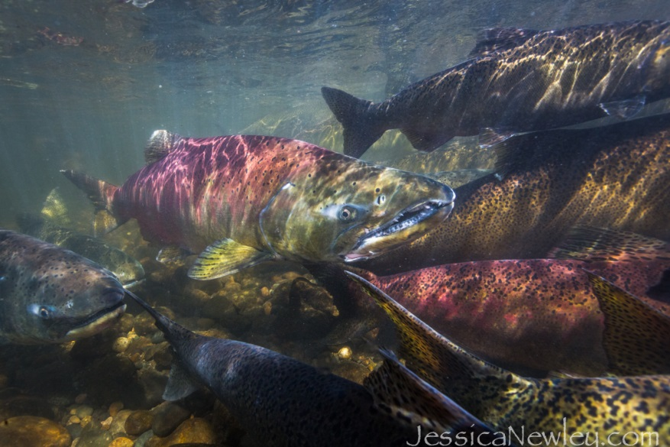
Use your interest and enthusiasm for marketing and graphic design to help inspire and encourage the community to get involved in local salmon enhancement efforts. This internship will allow you to use your creativity and develop your skills in marketing and graphic design as you assist the Skagit Fisheries Enhancement Group in its efforts to engage community volunteers in doing stewardship activities for local conservation efforts. We are interested in developing marketing and communications materials to expand our impact in both the digital and print markets. Intern will assist with creating and designing marketing materials and implementing communications plans for several upcoming events.

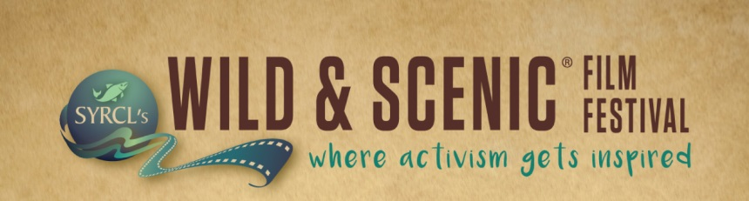
Qualifications
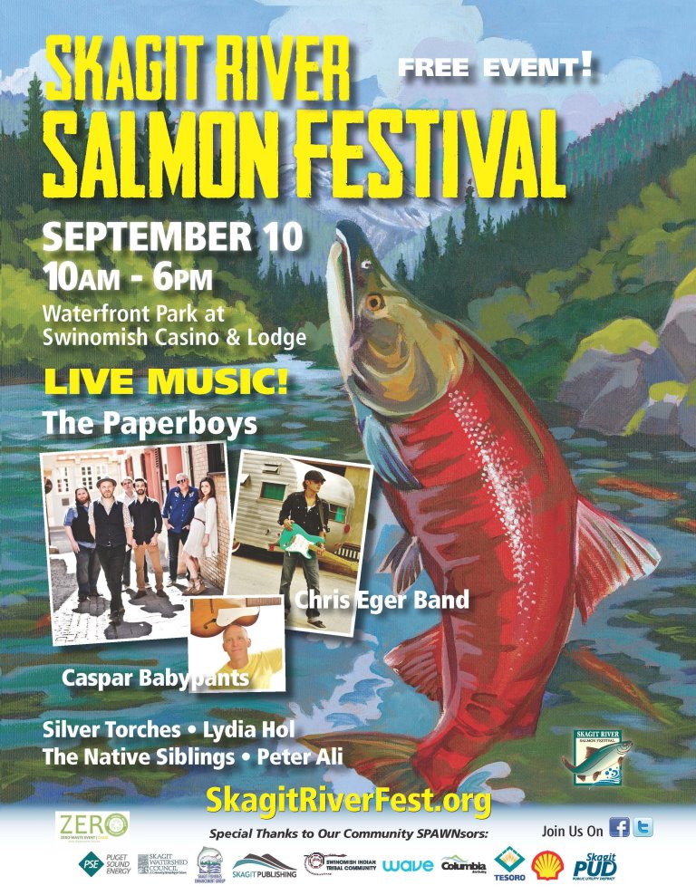
Applicants should have a background and interest in Graphic Design, Marketing, Communications and/or Journalism. Designing outreach materials for print, web, advertising and/or social media a plus. No prior knowledge about salmon is necessary, just an interest and enthusiasm for conservation and willingness to learn about local salmon enhancement activities.

Time Commitment
This is a volunteer internship that requires a time commitment of at least one weekday per week between 9:00 AM to 5:00 PM. Hours will vary depending on your availability.

Interested?
Please contact Alison Studley at 360-336-0172 for more information.
To apply submit a letter of interest, resume and weekday availability to astudley@skagitfisheries.org

Skagit Fisheries Enhancement Group is a nonprofit, tax-exempt charitable organization Tax ID# 94-3165939
under Section 501(c)(3) of the Internal Revenue Code.

Use your Creativity to Inspire Stewardship!

